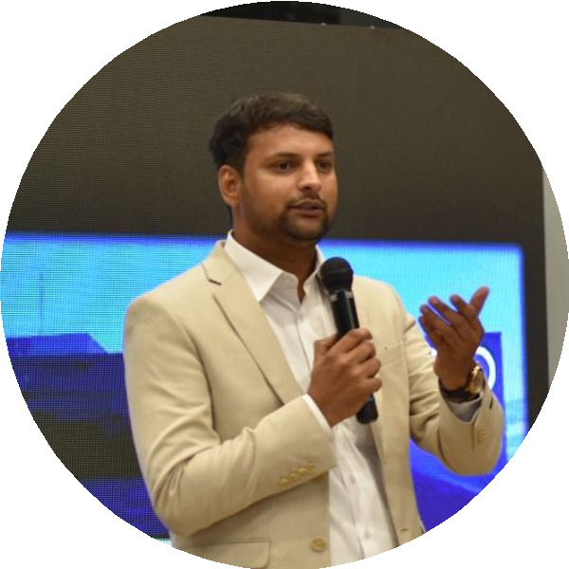
VIKRAM TIWARI
Sales and Marketing Manager

E 08889908090
@ bhptalfi@gmail.com
9 Nagpur, India

EXPERIENCE

Sales - Marketing Manager

Audi Nagpur / Raipur
11/2021 - Present Nagpur, India
Audi - A leading luxury automobile manufacturer
- Sales planning for New/Approved Plus Cars as per the business plan.
- Planned and executed marketing strategy aligned with business goals.
- Generate Leads from various sources - Cold Calls / Corporates / Digital / Events / Referrals
- Maintain good relationship with associations such as IMA / ICAI etc for corporate / bulk deals.
- Ensure excellent relationships with the Bankers and Financers.
- Stock Planning for the month to ensure Low TAT for deliveries
- Prepare Training Need Identification (TNI) G arrange Trainings for Sales team
- Ensure high Sales Satisfaction Index

Regional Service Manager - East & North India

Ofiinawa Autotech
06/2021 - 10/2021 Delhi, India
An electric two-wheeler manufacturer
- Maintain High Internal CSI Score of 9.0 G Above
- Established Motor Repair / CDC Repair Process for reducing TAT
- Conceptualizing customer service strategies
- Improved Dealer Service Standards by conducting Facility Audits

Sales Manager
VINS Motoring - HMSI Dealer 10/2016 - 05/2021 Bhilai HMSI Dealership
- Sales G Network Operations for the dealership.
- Ensure correct stock planning at counter and network.
- Target achievement as per business plan.

Area Manager - Customer Care

Mahindra G Mahindra Ltd
07/2013 - 09/2016 Nagpur/Raipur, India
A leading SUV manufacturer
- Headed service operations in Chhattisgarh with a focus on customer excellence
- Defined service standards and guidelines for excellent service delivery
- Enhanced customer satisfaction through on-time delivery
- Organized training sessions for the team through various training methods

Territory Manager - Service

Hero MotoCorp
06/2011 - 05/2013 Raipur, India
A leading motorcycle and scooter manufacturer
- Managed 7 Dealers, ensuring smooth operations and customer satisfaction
- Monitored post-service activities and resolved customer queries
- Established dealer networks and launched new markets

SUMMARY
I am a seasoned sales and marketing professional with over 18 years of robust experience in the automobile industry, specializing in luxury car sales, after-sales service, and digital marketing. My creative leadership has driven sustainable business growth through effective relationship management and innovative marketing strategies. I excel in planning and executing impactful events, and I have consistently achieved high customer satisfaction and retention rates

KEY ACHIEVEMENTS

Sales Manager Sfiills Contest
Ranked No.1 in Central Zone for Sales Manager Skills Contest in 03/2021 for Honda Motorcycles G Scooters India

s Capability Building Initiatives
Played an instrumental role in Capability Building through E-Learning Platform for Dealer Workforce in Mahindra G Mahindra Ltd

9 Rural Networfi Standardization
Standardization of more than 100 Rural Networks in Hero MotoCorp and TVS Motor Company

* Event Management Success
Conducted more than 20 successful events for Audi, enhancing brand visibility and customer engagement

EXPERIENCE

Assistant Manager - Service

India Yamaha Motor Pvt. Ltd
04/2010 - 06/2011 Pune, India
Manufacturer of motorcycles, scooters, and ATVs
- Handled After Sales Operation for 70% of Maharashtra
- Monitored post-service activities and maintained customer feedback timelines
- Conducted Mobile Service VAN Camps to enhance brand visibility

Territory Manager - Service

TVS Motor Company Limited
07/2007 - 04/2010 Aurangabad/Nagpur, India
An Indian multinational motorcycle company
- Standardized 60 Rural Networks in Maharashtra
- Trained technicians and supervisors to ensure high customer satisfaction
- Conducted classroom training programs for continuous improvement

EDUCATION

Post Graduate Diploma in Business Administration

Narsee Monjee Institute of Management Studies
06/2015 - 05/2017 Mumbai, India

Bachelors in Business Administration

Lovely Professional University
06/2012 - 05/2015 Phagwara, India

Diploma in Mechanical Engineering

Government Polytechnic, Nagpur
06/2004 - 05/2007 Nagpur, India

